**Lab 1 js**

1. Explain how var works in JavaScript. What is variable hoisting? Give a code example.

var is the method to declare variable

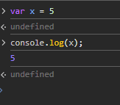

variable hoisting is variable is declared to the top of scope when call it without declaration.

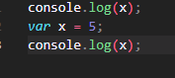

1. What is the scope of a variable declared with var inside a function? What about inside a block (e.g., an if statement)?

inside fun ----> block scope(accessable only in the fun)

inside block ----> declared globaly (accessable in all file)

1. List all JavaScript primitive types in ES5. Give an example of each.

1- Number --> var num = 5; console.log(x);

2- String --> var name = "mohamed"; console.log(x);

3- Boolean --> var check = true; console.log(check);

4- Undefined --> console.log(x); var x;

5- Null --> var x = null; console.log(null);

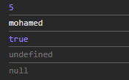 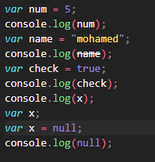

1. What is the difference between a primitive type and an object type? Give an example where this difference is important.

Primitive types like number and string are stored by value in the stack

Object types like object and fun are stored by reference in heap

Ex that diff is important: if we have tow variables and we need when change the value of one the second must change also in this case we should use object type

1. Create a number, string, and boolean using both literal and constructor syntax. Show the difference in their types using typeof.

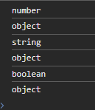 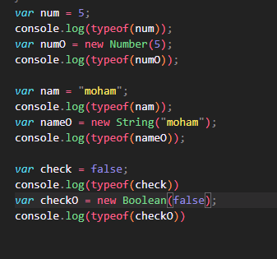

1. Why is it generally recommended to use literals instead of constructors for primitive types?

Literals 🡪 readable and simple and faster

7. Given the following code, what will be the output? Explain why.

var x = 123.4567;

console.log(x.toFixed(2));

console.log(x.toPrecision(4));



To fixed 🡪 return n digits after decimal point

Toprecision 🡪 return n numbers from the number

8-What is NaN? How can you check if a value is NaN? Give an example.

Nan 🡪 not a number

Check it using isnan() fun

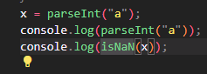 

9. What is the difference between parseInt, parseFloat, and Number? Give an example for each.

Parseint🡪 parse string to int

Parsefloat🡪 parse string to float

Number 🡪 parse string to number

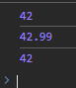 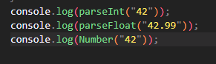

10. What is the difference between implicit and explicit type casting? Give an example of each.

Implicit when in the run convert to another type like the output of + number with string

Explicit like when convert from type to anther

 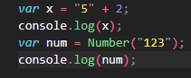

11. What will be the result and type of the following expressions? Explain your answer.

- true + 5

- "10" - 2

- 12 - "1a"

- 5 / 0

- 5 + undefined

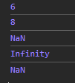 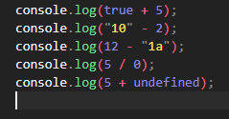

1🡪 true is converted to 1 then the addition process rturn 1 + 5 = 6

2🡪 “10” becomes Number (casting) then -2 from it

3🡪 “1a” converted to nan then 12 – nan return nan

4🡪 5 / 0 in othr languages return error but in js that tends to infinity

5🡪 any thing + undefined return nan

12. What will be logged to the console in the following code? Explain each step.

var a = "15.5"; declare and initialize a as a string

var b = +a; convert a to number and assign it to b

console.log(b, typeof b); prints b (number) and the type of it



13. What will be the output of:

var result = 20 > true < 5 == 1;

console.log(result);

Explain why.



True = 1

False = 0

Cuz 20 > 1 and 1 < 5 and 1 == 1 so this return true

14. Write a function that takes a string and returns true if it can be converted to a valid number, and false otherwise.

 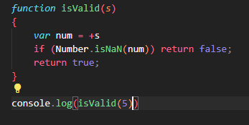

15. Write a program that prints all numbers from 1 to 20 using a while loop.

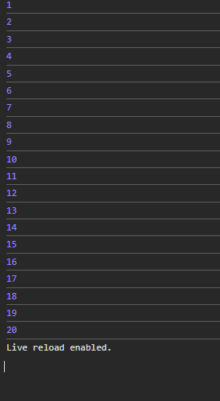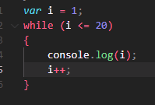

16. Write a program that asks the user to enter numbers until they enter 0, using a do...while loop. After the loop ends, print the sum of all entered numbers (excluding 0).

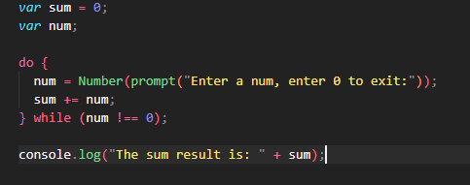

17. Write a program that takes a number from 1 to 7 and prints the corresponding day of the week using a switch statement. Use a for loop to test your program with all numbers from 1 to 7.

